ORACLE

academy.oracle.com

Academy

Database Programming with SQL

2-3: Comparison Operators

Practice Activities

Objectives

* Apply the proper comparison operator to return a desired result
* Demonstrate proper use of BETWEEN, IN, and LIKE conditions to return a desired result
* Distinguish between zero and the value of NULL as unavailable, unassigned, unknown, or inapplicable
* Explain the use of comparison conditions and NULL

Vocabulary

Identify the vocabulary word for each definition below.

|  |  |
| --- | --- |
| ESCAPE | This option identifies that the escape characters should be interpreted literally |
| IS NULL | Condition tests for null values |
| BETWEEN | Displays rows based on a range of values |
| inclusive | Including the specified limits and the area between them; the numbers 1-10, inclusive |
| LIKE | Selects rows that match a character pattern |
| IN | Tests for values in a specified list of values |

Try It / Solve It

1. Display the first name, last name, and salary of all Global Fast Foods staff whose salary is between $5.00 and $10.00 per hour.

Листинг:

SELECT first_name, last_name, salary

FROM f_staffs

WHERE salary BETWEEN 5 AND 10;

Результат:

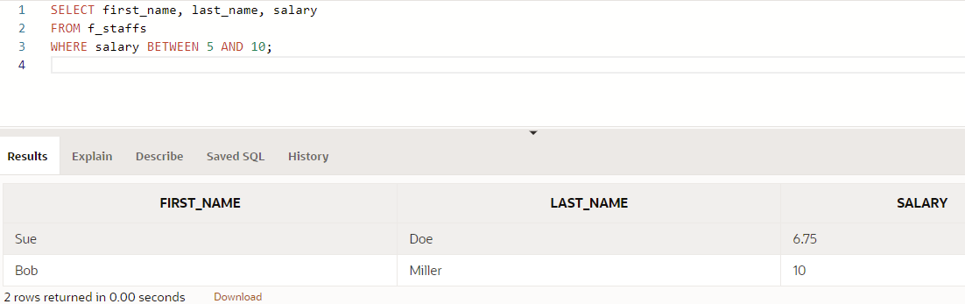

1. Display the location type and comments for all DJs on Demand venues that are Private Home.

Листинг:

SELECT loc_type, comments

FROM d_venues

WHERE loc_type = 'Private Home';

Результат:

1. Using only the less than, equal, or greater than operators, rewrite the following query:

SELECT first_name, last_name

FROM f_staffs

WHERE salary BETWEEN 20.00 and 60.00; (добавил сюда нужные арифм. операторы)

Результат:

1. Create a list of all the DJs on Demand CD titles that have “a” as the second letter in the title.

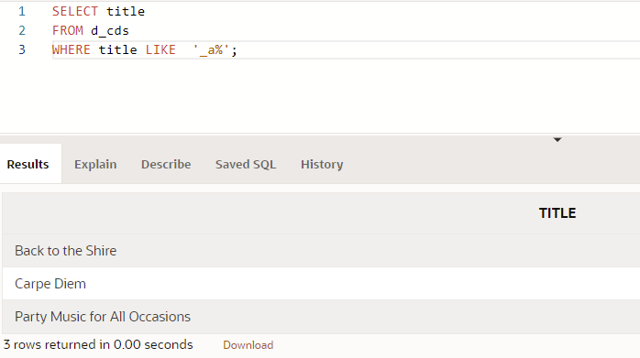

1. Who are the partners of DJs on Demand who do not get an authorized expense amount?

Листинг:

SELECT *

FROM d_partners

WHERE auth_expense_amt = 0 OR auth_expense_amt IS NULL;

1. Select all the Oracle database employees whose last names end with “s”. Change the heading of the column to read Possible Candidates.

1. Which statement(s) are valid?

WHERE quantity <> NULL;

WHERE quantity = NULL;

WHERE quantity IS NULL;

WHERE quantity != NULL;

1. Write a SQL statement that lists the songs in the DJs on Demand inventory that are type code 77, 12, or 1.

